Power BI Assignment 2 – DAX & Data Visualization

Fathima minha.p
Calculated Columns:
● Create a Calculated Column for 'Category Type': Add a calculated column in the Order Details table that combines the 'Category' and 'Sub-Category' columns into a single 'Category Type' column.
Select the order details column right click select the new column add the function.
Category type = 'Order Details'[Category]&'Order Details'[Sub-Category]

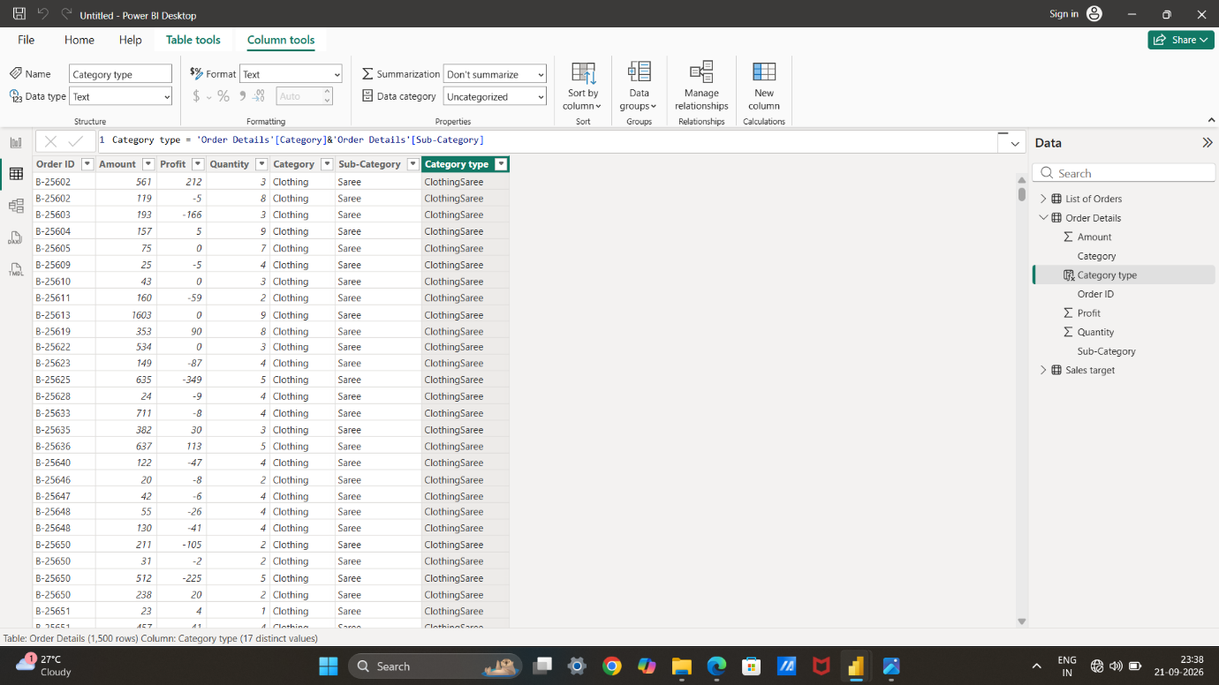
● Calculate Revenue per Order in Order Details Table: Create a calculated column in the Order Details table to compute the revenue (Amount * Quantity) per order.
Select new column add the function revenue = 'Order Details'[Amount]*'Order Details'[Quantity].
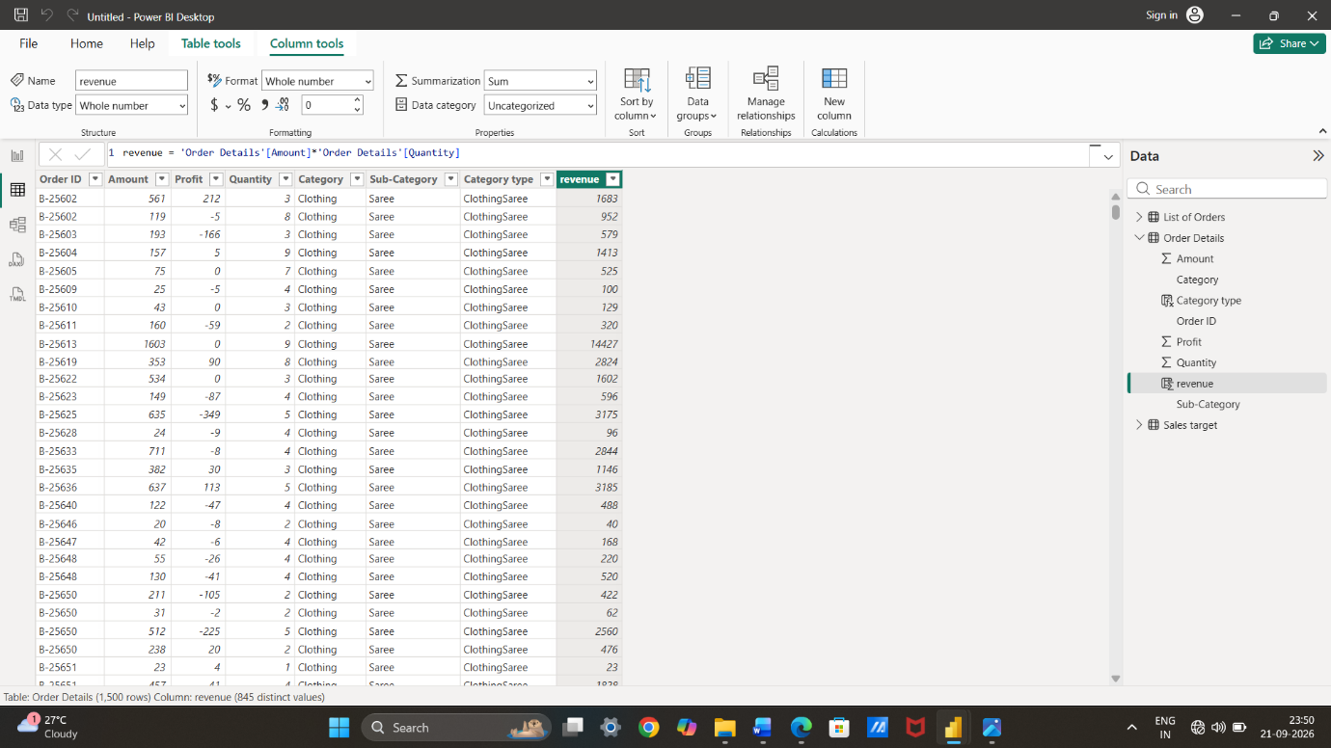
● Create a Calculated Column to Categorize Sales: Add a calculated column named ‘Sales Category’ in the Order Details table that categorizes each order as 'Above Average' or 'Below Average' based on the Amount value.
Create a new column and add this functions
sales category = IF('Order Details'[Amount]>AVERAGE('Order Details'[Amount]),"above average","below average").
Calculated Measures:
● Calculate Order Count: Define a measure to count the total number of orders in the Order Details table.
Select the new measures column and give the function.
order count = COUNT('Order Details'[Order ID])
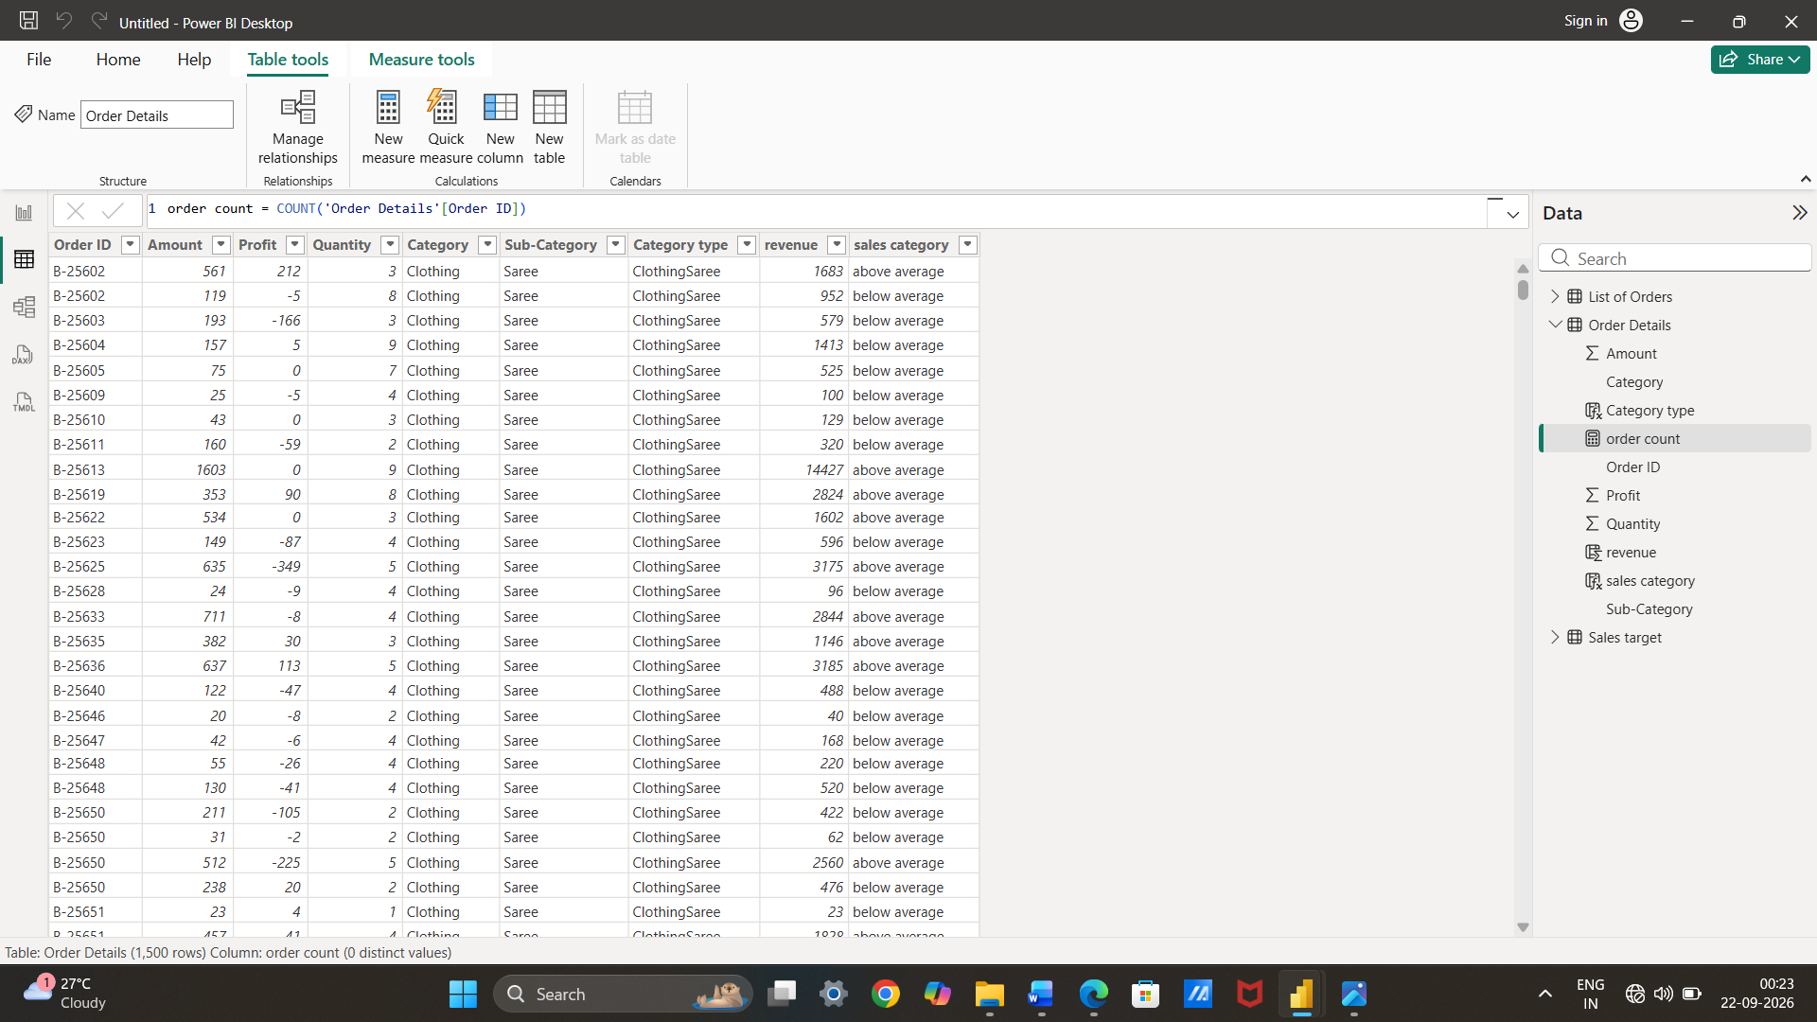
● Calculate Average Profit in Delhi: Create a measure to calculate the average profit for orders placed in Delhi.
Select the new measure and put this functions.
average profit in Delhi = CALCULATE(AVERAGE('Order Details'[Profit]),'List of Orders'[City]="Delhi")

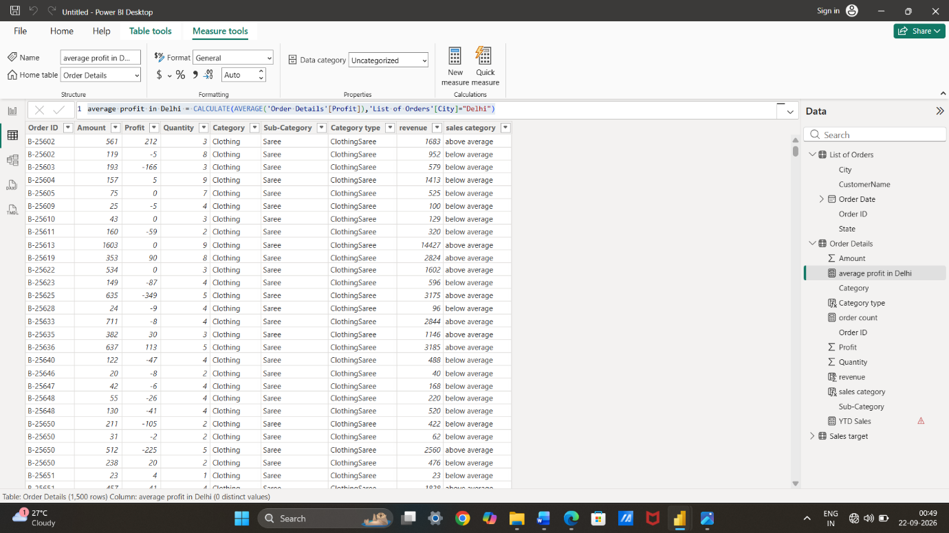
● Calculate Year-to-Date (YTD) Sales: Define a measure to calculate the total sales amount accumulated from the earliest order date up to each order date.
Select new measure column add the function
YTD Sales = TOTALYTD(SUM('Order Details'[revenue]),'List of Orders'[Order Date])
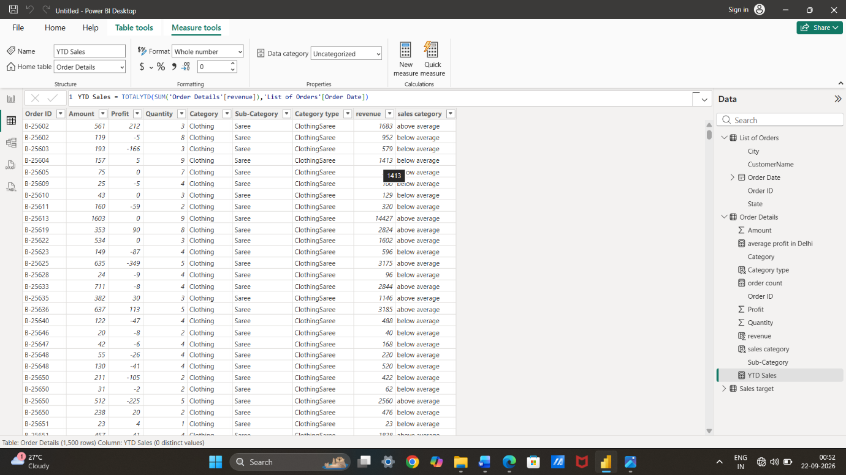
Data Visualization:
Sales Target Achievement by Category: Compare actual sales with sales targets by category using a clustered column chart. 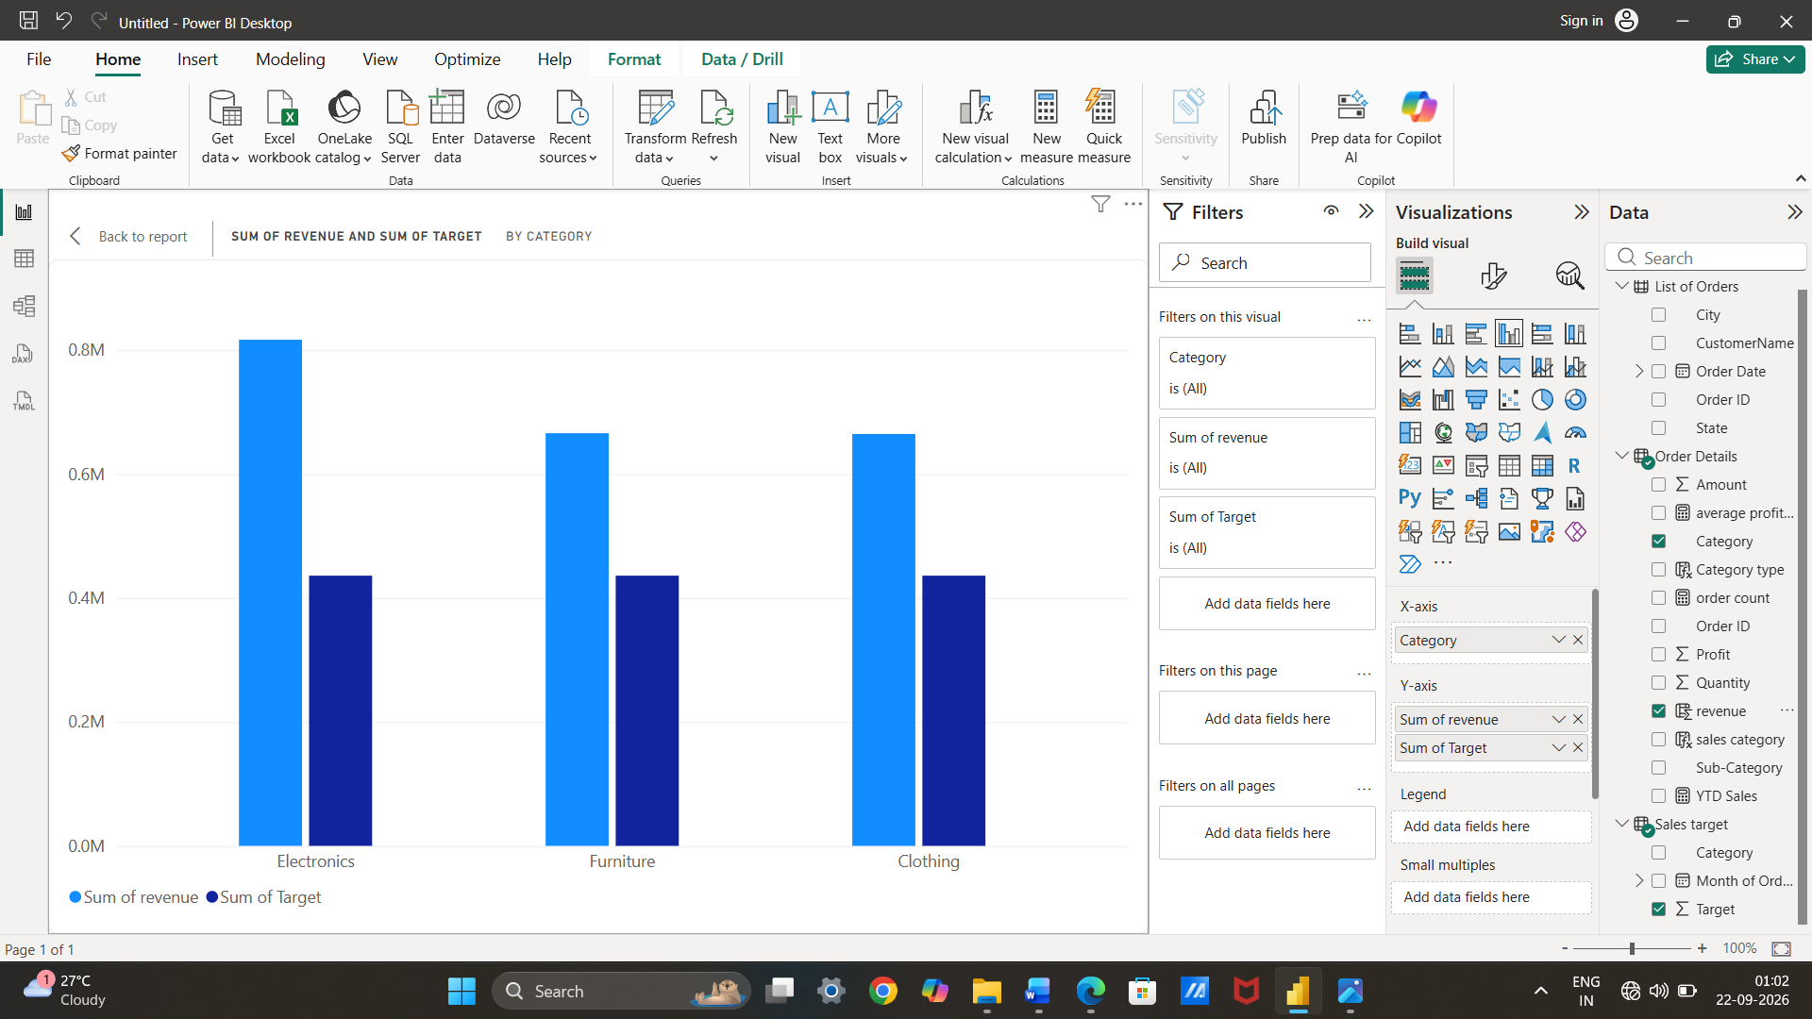
Max Profit Margin by Sub-Category: Analyze the maximum profit margin for each sub-category of products using a donut chart.
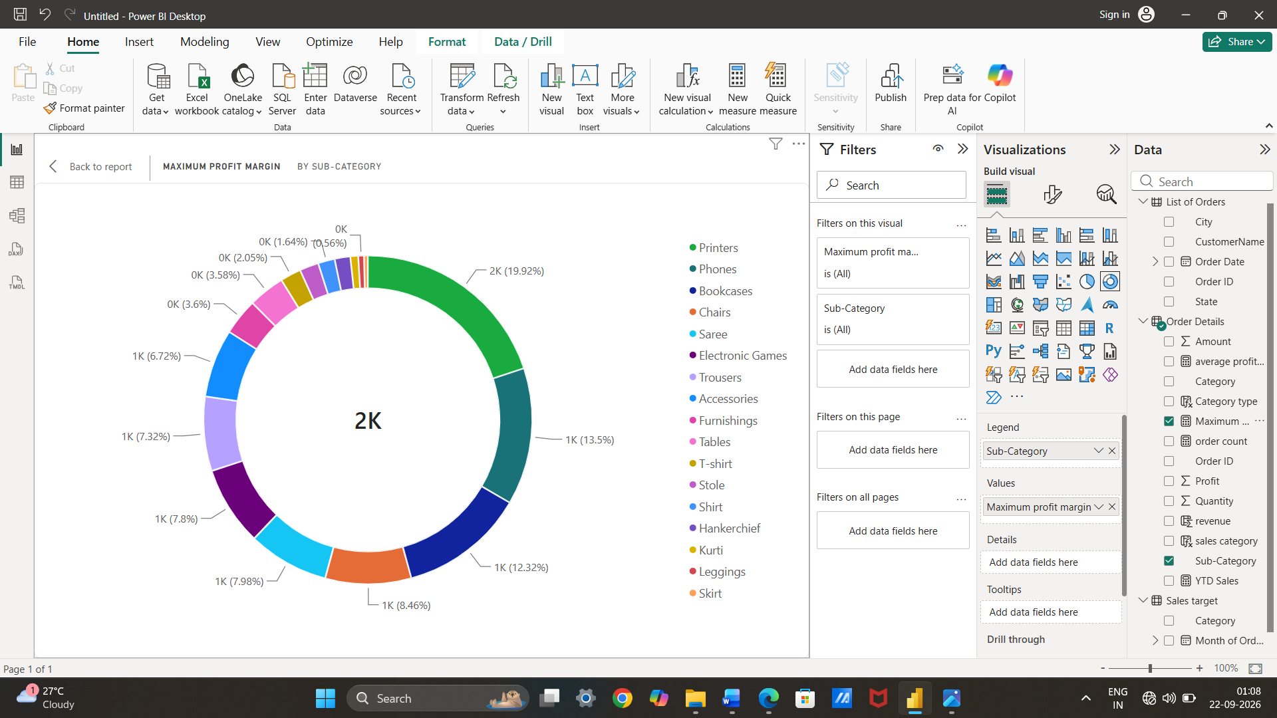
Monthly Sales Trend: Show the trend of monthly sales over time using a line chart.
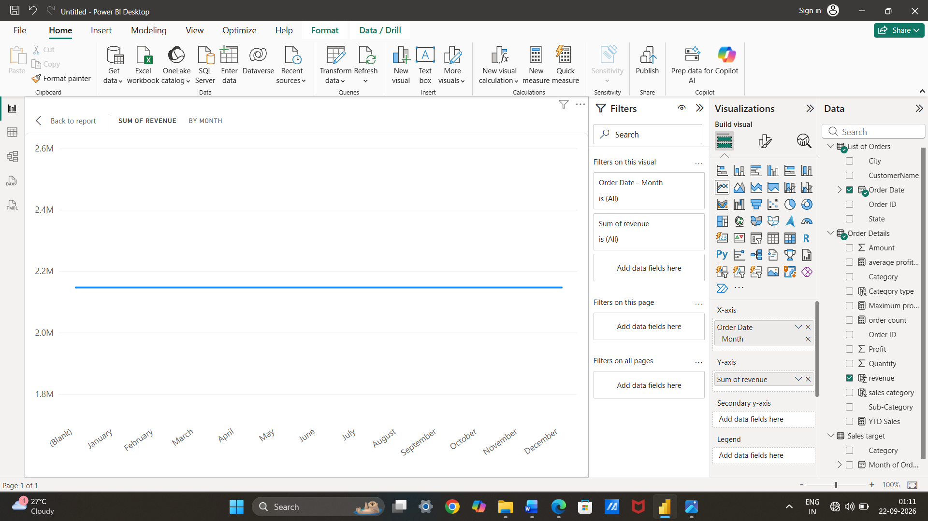
Comparison of Profit and Quantity by Sub-Category: Compare the relationship between profit and quantity sold for different sub-categories using a scatter chart.
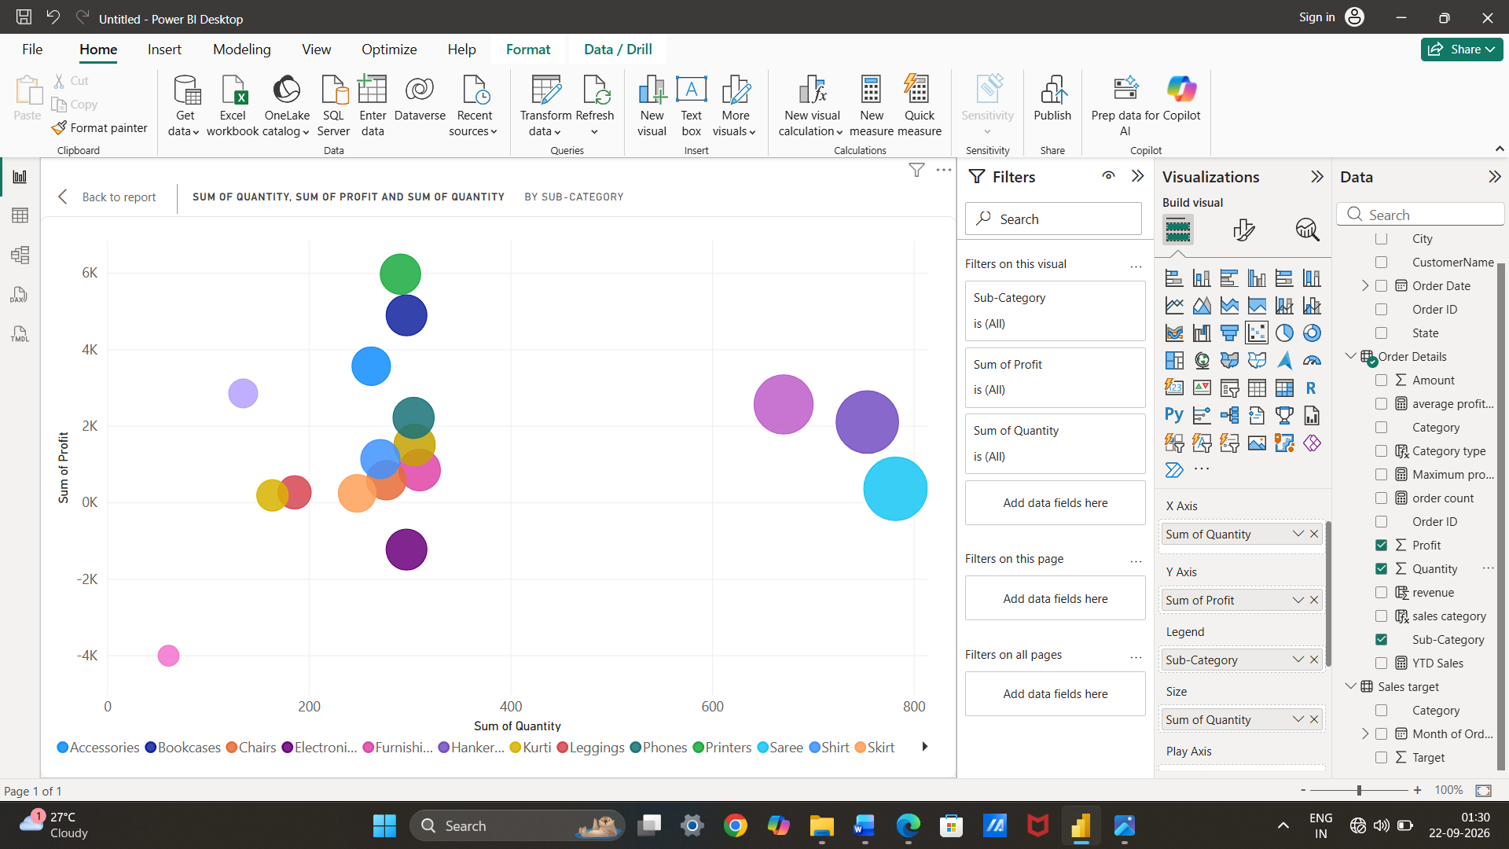
Comparison of Total Sales Amount and Target: Create cards to succinctly display the total sales amount alongside the sales target for quick comparison and analysis. Also, create a multi-row card to display the minimum target for each segment.
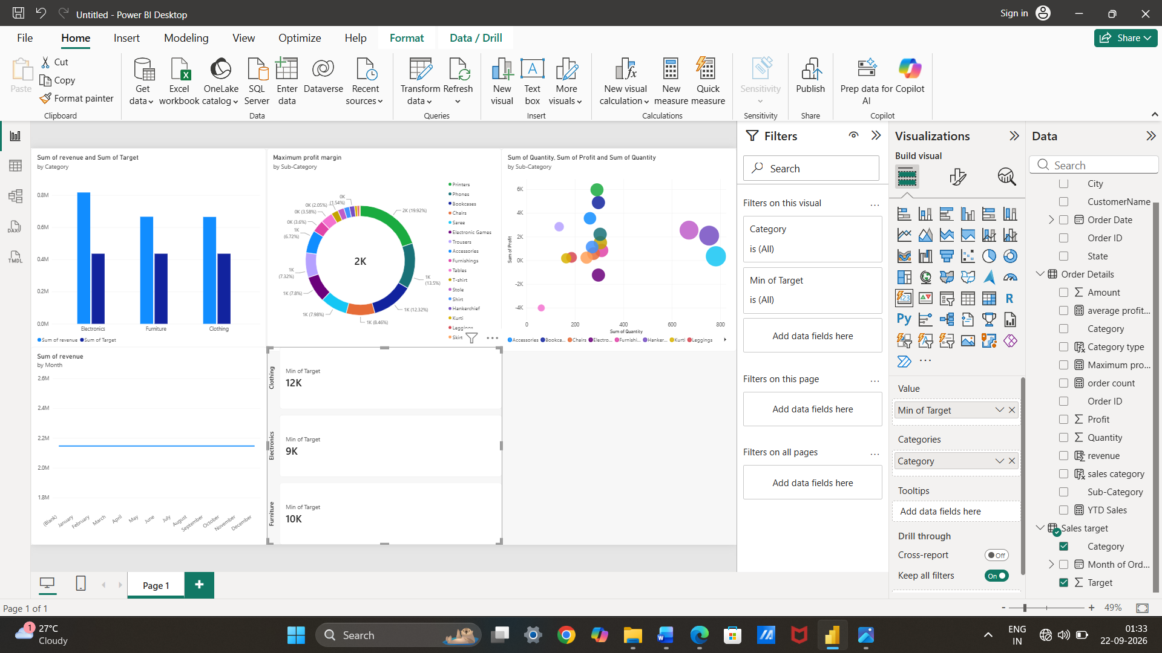
Sales Performance Matrix: Build a matrix view to analyze how actual sales compare to sales targets across different categories and months.
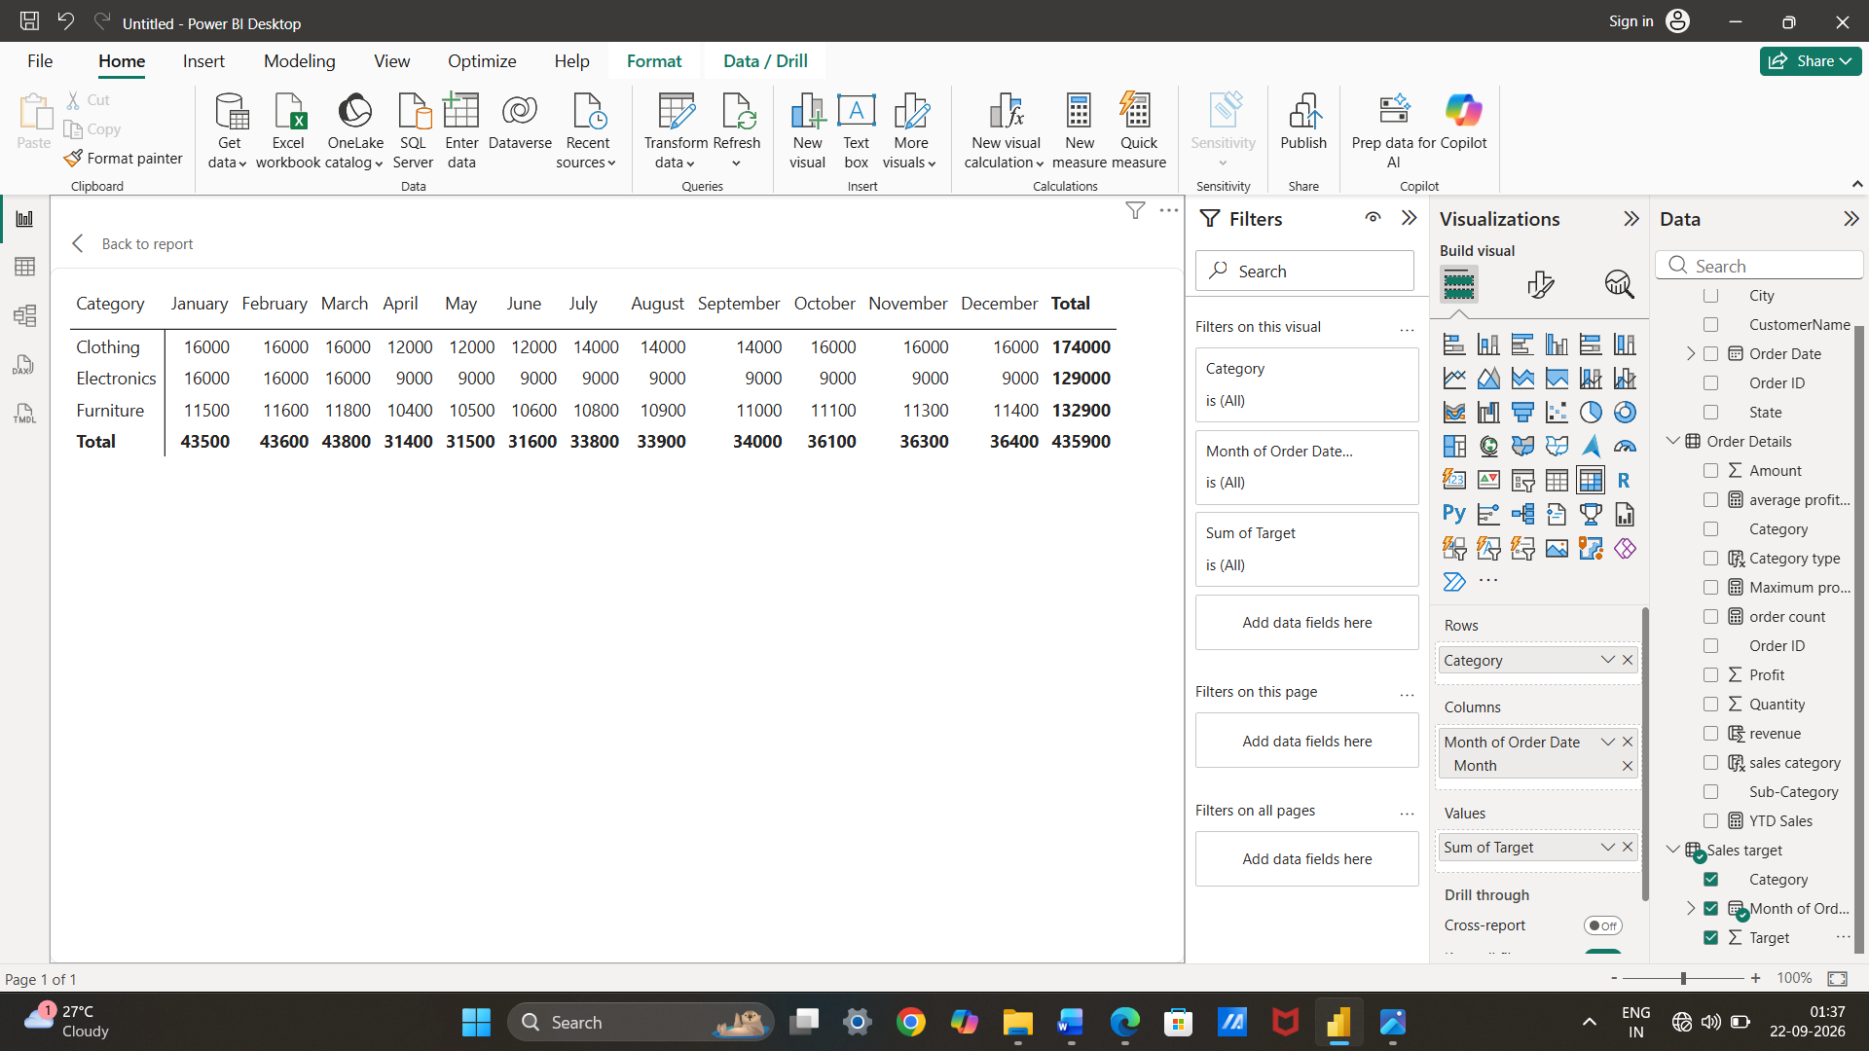
Geographic Sales Analysis: Visualize total sales on a map by city to identify regional sales patterns.
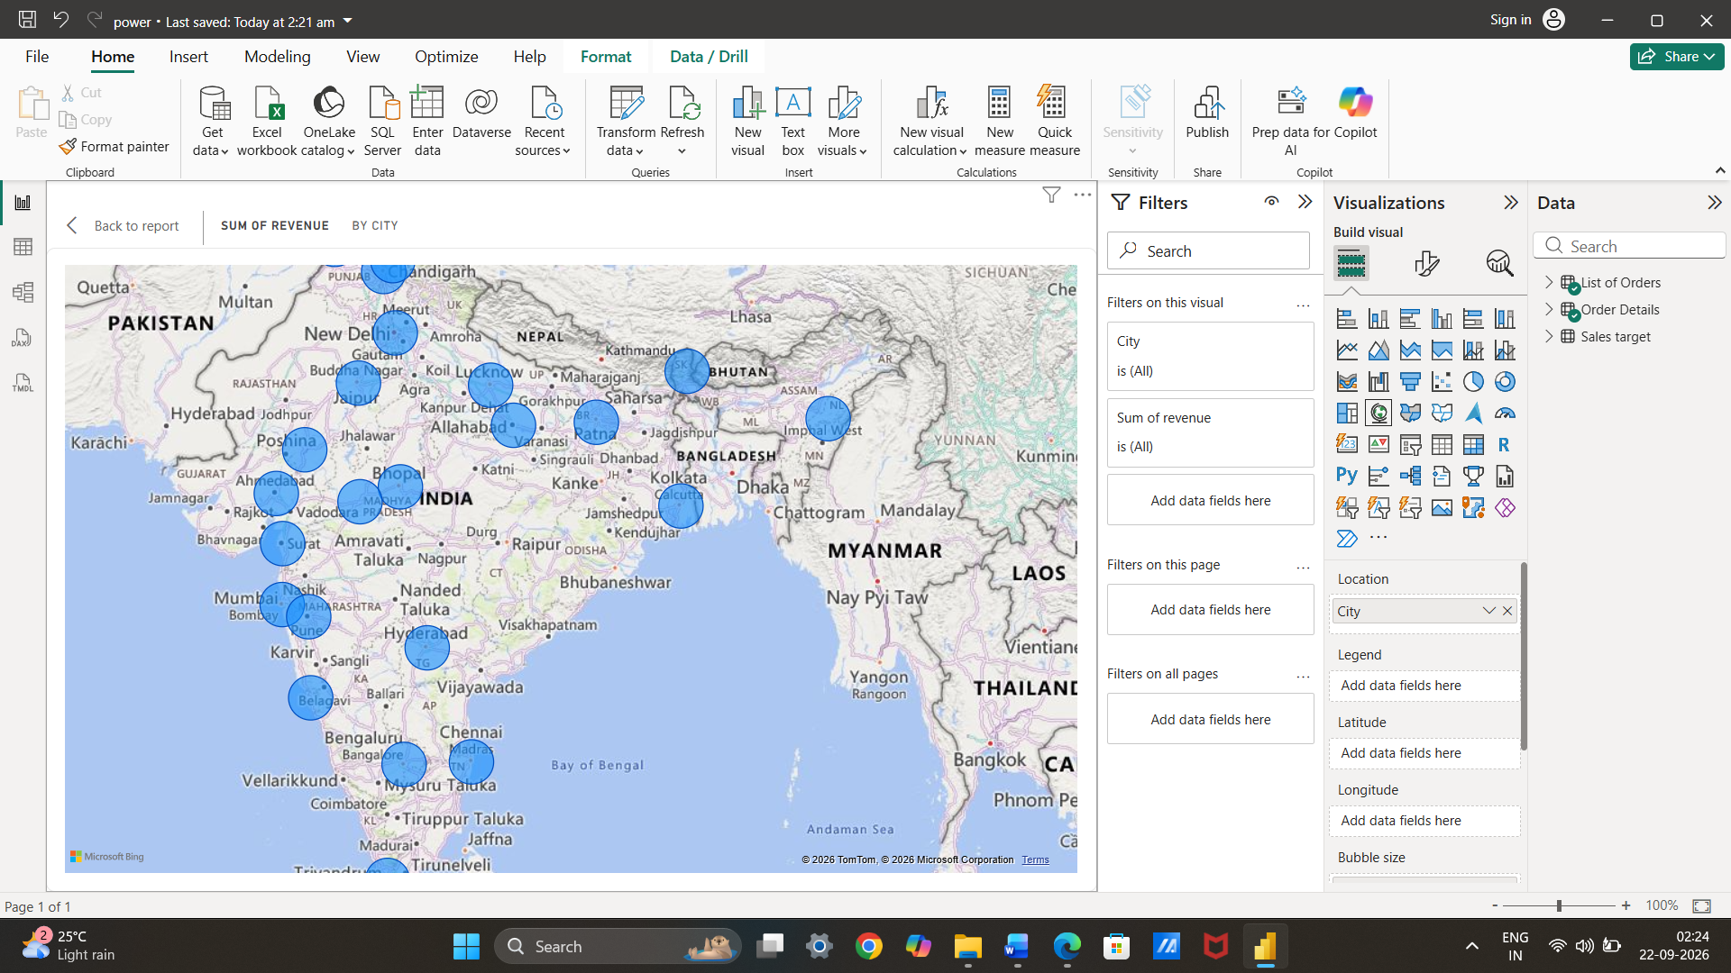
Sales Distribution by Sub-Category: Represent the sales distribution across different sub-categories using a treemap.
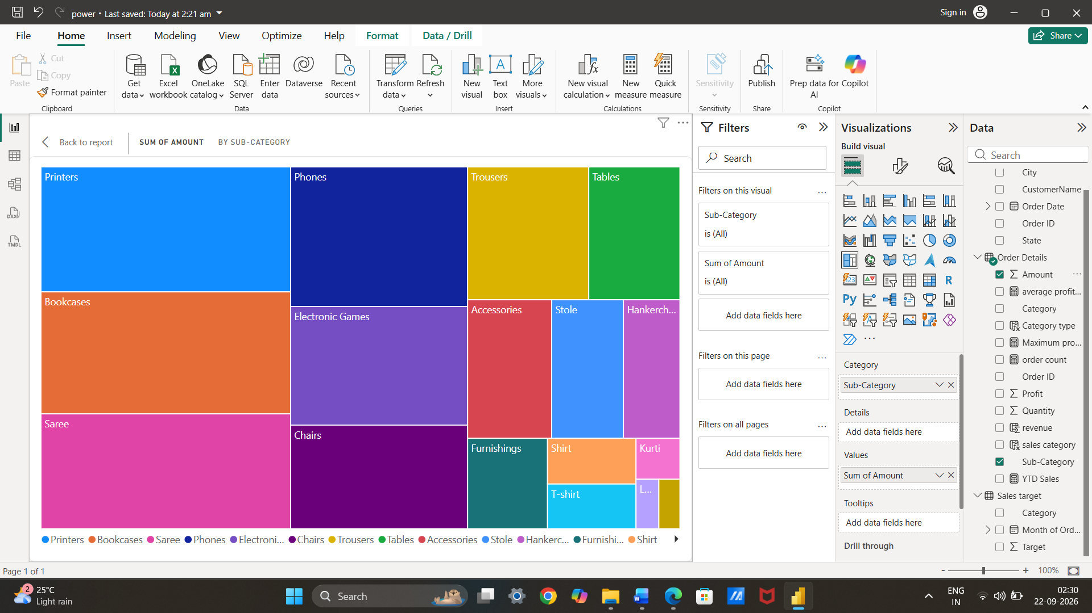
Order Count Analysis by State: Create a funnel chart to visualize the distribution of order counts across different states
